Git and eChronos Procedures for Contributors

Contents
Setup Git (for Windows)
Downloading
Installing
Launching
Built-in Help
Save the Changes
Commit the Changes Locally
Check for Changes to Remote Repository
Use Log to Verify the Details
Pull
Status
Push

Setup Git (for Windows)

Downloading
Use one of the following links, and click on the appropriate download link in your browser.
Git for Windows @ git-scm.com
Git for Windows @ github.com
Or you can just search online for 'Git for Windows' and follow an appropriate result there.

Installing
The download should have been an “EXE” file, so double-clicking will launch the installation. At this point you can choose to accept all the defaults by clicking 'Next' throughout the rest of the installation and skip to the next section. The defaults are probably fine for most users. My own installation only involved a single minor change (to add the Quick Launch button).

If you want to see some of the highlighted details of installation you can follow along through the rest of this section.

Select Components
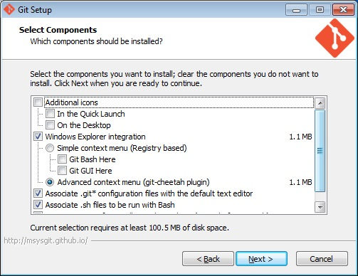
I wanted the option for Quick Launch (which is unchecked in the image by mistake), but did not want the Desktop icon.

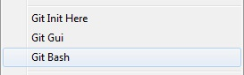
I also wanted the context menu. It shows options for Git when you right-click anywhere in Windows.

PATH Environment
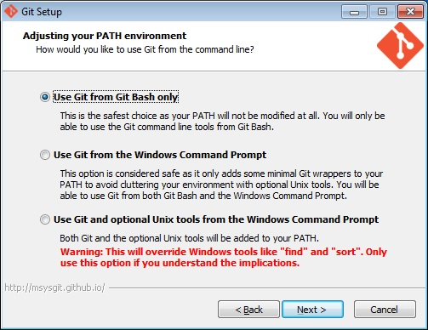
The default here is good, especially if you don't know what all this means. Basically you will use the “editor” that you are currently installing to run commands instead of using the one built into Windows.

Configuring the line ending conversions
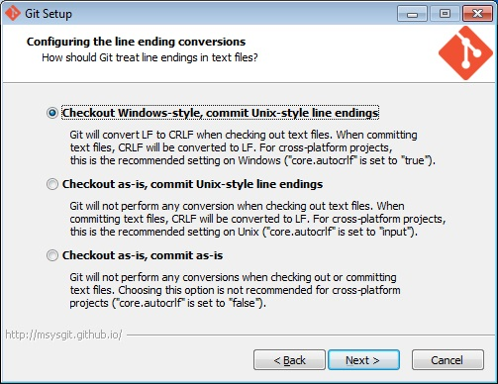
Yeah, this is gobbeldeeguk. Just accept the default. It's worked for the team so far.

Launching
After installation, both 'Git Bash' and 'Git GUI' will show up in your Start Menu
You want to run 'Git Bash' for the purposes of this guide, but are more than welcome to learn whatever the heck 'Git GUI' is good for and write your own everlovin guide.

Built-in Help
If you need quick help (probably later once you've started working with Git commands) you can enter the following commands in Bash.
Warning! The following commands will launch your browser if it isn't already open!
$ git help git - displays 'help index'
$ git help <command> - displays help for whatever command you enter

Standard Git Setup
Enter your user name.

$ git config --global user.name “Optimus Prime”

Enter your email address.

$ git config --global user.email 1GreatLeader@cybertron.net

Check what you just set.

$ git config –list
...
user.email=1GreatLeader@cybertron.net
user.name=Optimus Prime
...

Standard eChronos Procedures

Cloning eChronos from GitHub

Typically the command looks something like this:

$ git clone git@github.com:Carolla/Adventurer.git eChronos

The 'eChronos' on the end is the name of a new folder that will be created in the current directory. The files from the repository on GitHub will be copied there. You can change this name to whatever you like.

Importing eChronos into Eclipse
Needs Content!

Making Changes to eChronos Files
Need a new Sub-Heading!!

Save the Changes
Save in Eclipse to update the file in your Working Directory.

Using Git, Stage the changed file or files. This prepares the files to be committed permanently to your local repository.

Commit the Changes Locally
Commit to submit permanent changes to your local repository.

Check for Changes to Remote Repository
You must do a fetch BEFORE checking status for this to work! Calling status without first calling fetch will not update info from the remote repository.

To see what I mean, do a git status first:
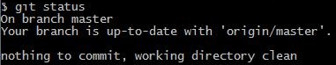

Now do the fetch:
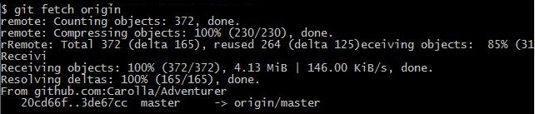

Now when you call status, there's an obvious difference!
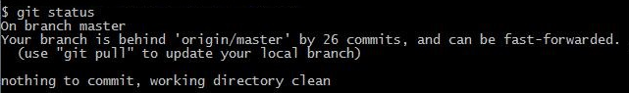

Use Log to Verify the Details

Git log shows you local commits
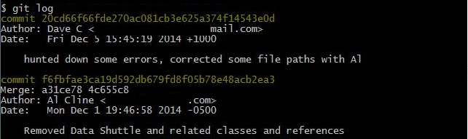

Git log origin shows remote commits
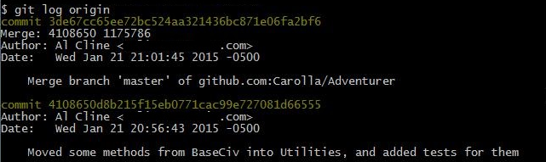

Pull
Using pull will do a combined fetch/merge. We already did a fetch, but you can use it just as easily (or more?) as merge.
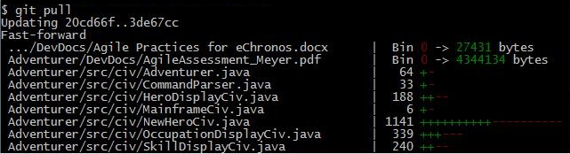

Status
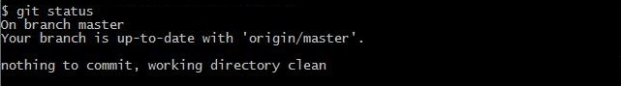

Push

$ git push

Finally! All that work, but now our changes are saved to the remote repository!

Committing a file change to the repo, local and to GitHub.
Synchronizing the local and remote repos (pulling file changes down to local machine)
Merging two files that have conflicts.
Refreshing a previously deleting file, that is, restoring a backed up version.

